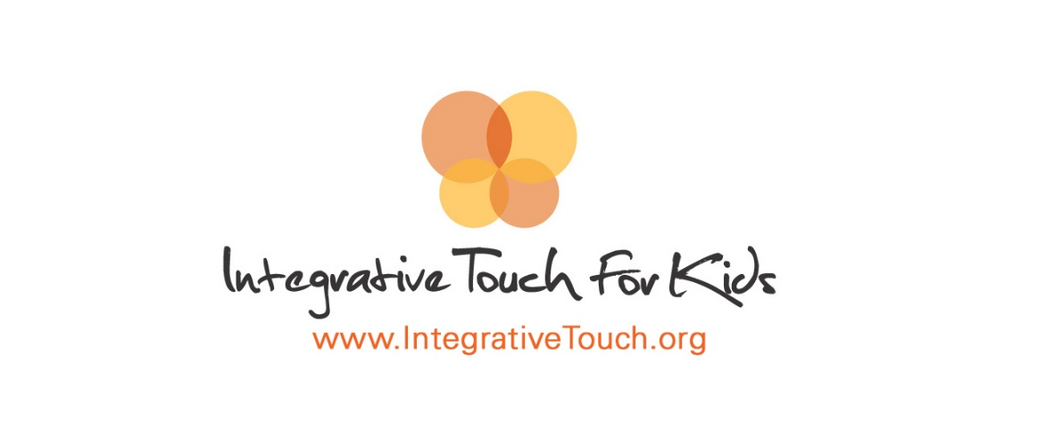

Organization Name:

Integrative Touch for Kids

Organization Background:
Integrative Touch for Kids (ITK) was created when founder, Shay Beider's life was forever changed by one little girl in the hospital, who was frightened and alone as she was about to undergo surgery. As a pre-med student, Shay witnessed this little girl go under anesthesia in a state of intense fear and in that moment something inside of her said, "No. It doesn't have to be this way." Shay understood the profound importance of caring for the whole child in body, mind, heart and spirit. Integrative Touch for Kids was founded to honor that little girl, to protect children from unnecessary suffering, and to address all aspects of the healing process. Since its inception in 2005, ITK has grown to be a leader in the field of pediatric integrative medicine, developing a first of its kind Whole Child, Whole Family, Whole Community wellness model called "Health-Caring" for thousands of children and families in need.

Internship Project Title
Integrative Health Student Internship

Project Description:
The selected candidate(s) for this position will be extensively involved in both the office and hospital setting as seen fit by the organization’s staff. Integrative Touch for Kids will work with prospective candidates and interns directly, incorporating them into roles in which they will thrive in order to help the overall mission of the organization. Students will have the opportunity to work in our Hospital Heroes program, the only one of its kind in the country, where families in crisis are provided no cost support that includes everything from integrative healing therapies to visits from counselors or other skilled professionals who can provide comfort and moral support. Students can also help in data documentation, collection, and analysis as it pertains to our Hospital Heroes program. Administratively, Integrative Touch for Kids will provide meaningful office work experience utilizing the candidates’ skills which include but are not limited to grant writing, social media and networking, and event planning. Integrative Touch for Kids also promotes a wellness culture wherein student interns can take part in quarterly wellness events to receive free treatments from healers around the Tucson area. Students are required to commit for at least one academic year or two semesters.

Internship project keywords

Community health service
Maternal/Infant Health
Program Planning
Data Analysis
Other Integrative Healing

When: When do you want the work done? Check all that apply.
Spring 2019 and Summer 2019

Where:
Organization Mailing Address: 8340 N. Thornydale Rd #110-153, Tucson, AZ 85704

Address where Student will work (if different from above): 5675 N Oracle Rd, STE 3201, Tucson, AZ 85704
​

Student Characteristics:
A successful candidate will be organized and responsible for all work assigned to them. Student interns will be assigned work that is vital to the success of the organization as well as be ambassadors for our programs. Therefore, student interns must be reliable and committed to our mission and objectives which are to create a wellness system that is designed to include the whole child, whole family, and whole community.

Level of Expertise Needed:
We are looking for both graduate and undergraduate interns.

Supervision
The intern will be supervised directly by Executive Administrator, Raphael Pacheco, as well as assigned duties by our Program Coordinator, Katie Frazee, and Executive Director Shay Beider.
Shay has been a pioneer and leader in the field of Integrative Medicine and the Healing Arts for the past fifteen years. She is the founder and Executive Director for Integrative Touch for Kids (ITK), a non-profit organization whose purpose is to enhance well-being, minimize suffering and facilitate healing for children with special medical needs and their families (www.integrativetouch.org). ITK works nationally with families and children, volunteers, hospitals, and other strategic partners to provide healing services, consultation, education, program development and support.
Katie has a strong commitment to wellness, community, and service. She is passionate about modernizing health education to empower and cultivate whole beings and whole systems. Katie currently serves as the Program Coordinator for Integrative Touch for Kids, a local wellness non-profit that is working to model the return of healing and humanism in health care. Katie draws on her experience with biological and social research through her work as a Biological & Forensic Anthropologist. She is eager to share her unique gifts and learn how to better support our community.
Raphael graduated with a Master’s in Business Administration from the University of New Mexico in Albuquerque in 2016. Raphael has worked in the nonprofit sector for over two years specializing in grant planning, fund development, as well as developing public policy at the state level. In his current role, Raphael serves as the Executive Administrator for Integrative Touch for Kids and uses his experience in program development to lead the organizations intern and volunteer team.

Compensation/Benefits
At this time, we are unable to provide compensation for our student interns. However, research conducted by students pertaining to program data will be included and credited when presented or published.

Application Contact Information
Potential interns should apply directly by sending their current résumé and cover letter to Raphael at raphael@integrativetouch.org

