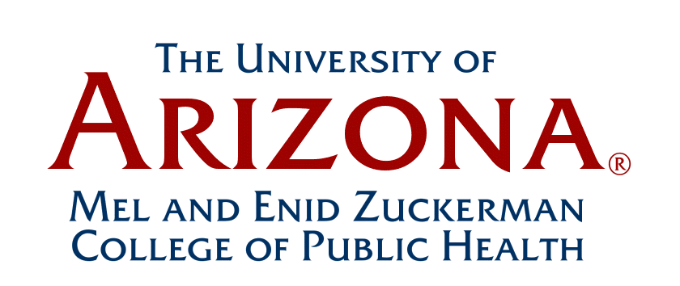

Faculty Assembly Minutes
September 19, 2014
“Final”
12:00-1:30 pm
Drachman Hall A116

Faculty Present: John Ehiri, Acting Chair (on behalf of Dan Derksen)
Gail Barker (via video conference-Phoenix), Paloma Beamer, Heidi Brown, Jeff Burgess, Robert Canales, Zhao Chen, Leslie Dennis, John Ehiri, Howard Eng, Kacey Ernst, Janet Foote (via videoconference-Phoenix), Stephanie Griffin, Iman Hakim, Robin Harris, Elizabeth Jacobs, Yann Klimentidis, Mary Kay O’Rourke, Kelly Reynolds, Denise Roe, Cecilia Rosales,
Nicky Teufel-Shone, and Nicole Yuan

Other MEZCOPH Personnel:
Kathleen Crist, Coordinator, MEZCOPH Academic Curriculum and Faculty Affairs
Chris Tisch, Assistant Dean, MEZCOPH Student Services & Alumni Office

Guests: Katharine Weiss, Local Coordinator, Enroll America
- Review of May 16, 2014 Meeting Minutes:
The May 16, 2014 Faculty Assembly meeting minutes were approved by all faculty members present.

- Introduction of New Faculty Members Present:
Jeff Burgess introduced Stephanie Griffin, who recently graduated from the UA in August 2014, with a PhD in Environmental Health Sciences and a multidisciplinary minor in Health Economics. She recently joined the MEZCOPH faculty as a non-tenure elgible Assistant Professor in the Division of Community, Environment and Policy. Her research efforts are focused on occupational health and safety in fire fighting and mining.

- Introduction of New Faculty Assembly Chair:
John Ehiri announced that Dan Derksen has stepped down as the Chair of the MEZCOPH Faculty Assembly after his 2-year term ended this past summer. John reported he put a “call out” and received several nominations for a new faculty assembly chair. From these nominations, Beth Jacobs has accepted the nomination. Htay Hla will set up a survey monkey for the faculty to officially vote to approve Beth Jacobs’ nomination as the new chair.

- Dean’s Report: (Iman Hakim)

- RCM2:
Iman stated that at this time, there are currently no updates to report regarding RCM2. However, the UA administration has called for a meeting next month with UA College Deans to discuss RCM2.

- MEZCOPH Divisions Moving Toward Departments:
Iman reported that the three MEZCOPH Divisions will be officially moving to departments. Iman stated that further details of the Divisions’ transition to departments will be discussed at the MEZCOPH December 2014 retreat.

- College Hiring Plan: Iman reported that hiring of College faculty is going as planned. Dr. Kaplan’s recruitement and joint hire negotiations with AHSC, are currently being discussed. Iman also reported that Dr. Elizabeth Calhoun has been appointed tenured professor in the CEP Division of MEZCOPH, with a joint appointment in the Department of Surgery at the College of Medicine. Dr. Calhoun will also join the UA Cancer Center as a member of the Cancer Prevention and Control Program. In addition, Iman also reported that the recruitement and hiring of a development director for the AHSC Colleges is currently underway.

- Grant Announcements:
Iman reported that the UA Zuckerman College of Public Health has received a $3.6 million HRSA Grant ot Impove the Nation’s Public Health System (Doug Taren, PI) (see UA grant announcement below for further details). Iman also reported that MEZCOPH was awarded additional HRSA grant funding to support our College’s graduate student public health internship/traineeship program in underserved areas (Doug Taren, PI).

In addition, Iman reported that Dr. Francisco Moreno and the Office of Diversity & Inclusion along with various colleagues from AHSC were awared the NIH PRIDE 25 grant, which is geared to train diverse young faculty and transitioning postdocs in research careers, in areas covered by the scope of Heart, Lung, and Blood Institute.

Iman also reported on a call for UA Strategic Priorities Faculty Initiative (SPFI) application proposals. The SPFI provides funding to hire faculty, who advance the Univesity’s strategic priorities set out in the UA’s “Never Settle” strategic plan and provide the Unveristy’s diverse student body with access to a research-based education. Iman has received a proposal request for a MEZCOPH SPFI hire. The deadline for the SPFI application submission is November 1, 2014 (see attachment below for futher information):

- Research Office Update: (Jeff Burgess, Associate Dean for Research)
Jeff Burgess gave an overview of the MEZCOPH Research Office’s preliminary plans and objectives. Listed below are key points from his update:

Objectives:
- Address public health through research
  - Improve faculty support
  - Improve AP/postdoc/student support
- Double research funding
  - By 2020 relative to 2010

Challenges/Opportunities:
- Mentorship
- Knowledge about research opportunities
- Assistance in submitting grant proposals
- Biostatistics support
(Root cause analysis)

Please contact Jeff Burgess if you have any questions, comments or planning suggestions for the MEZCOPH Research office.

- Enroll America: (Katharine Weiss, Local Coordiantor for Enroll America)
Katharine Weiss gave an over regarding “Enroll America”, which is a nonpartisan 501(c)(3) organization whose mission is to maximize the number of uninsured Americans who enroll in health coverage made possible by the Affordable Care Act. Enroll America works collaboratively with many health care partners to ensure that Americans know how and where to sign up for health care coverage. Katharine stated that Enroll America would like to get UA students involved (e.g. assist with service learning projects, etc.). Katharine stated she is available to speak with students in MEZCOPH courses.

- Other Announcements:

  - Action Items and Timeline for Internship Presenters & Students Graduating Fall 2014
Chris Tisch gave an overview to the faculty regarding MEZCOPH action items and the timeline for internship presenters & students graduating fall 2014 (please see attachment below for further details):

  - Future Faculty Meetings:
Beth Jacobs addressed the faculty and stated that she values their time. Beth commented that if she is officially elected as the new Chair of the MEZCOPH Faculty Assembly, she will try to utilize the faculty assembly meeting time wisely. Beth asked the faculty to please send her three “concerns” or topics that they would like to see addressed at future faculty assembly meetings. We need a list of College issues from the administration, so faculty can focus on these issues. Beth stated that she hopes the faculty would see the relevance of these faculty meetings for faculty governance, and therefore attendance would increase.

  - UA Faculty Senate Reports:
Robin Harris commented on the importance of faculty governance. Currently, the UA Faculty Senate is working on P&T issues and developing a formal proposal (open discussions). Faculty requested that the current MEZCOPH UA Faculty Senate representative send email reports from the UA faculty senate meetings to the MEZCOPH faculty.

Meeting adjourned at 1:15 pm.

Next Meeting:

- The next faculty assembly meeting is scheduled for October 21, 2014.

__________________________
Changes or corrections to the minutes should be submitted to:
Kathleen Crist, Coordinator, MEZCOPH Academic Curriculum and Faculty Affairs Office

