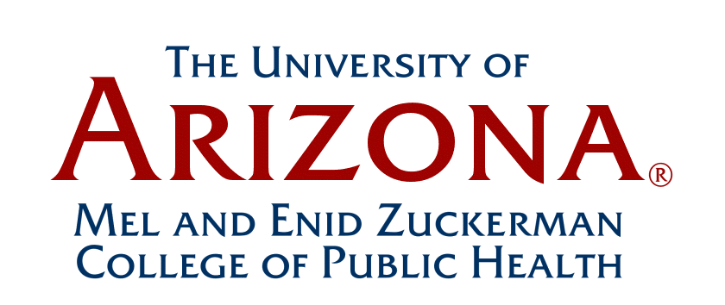

Faculty Assembly Meeting Minutes
March 2, 2018
12:00-1:00 pm
Drach A116

Primary Faculty and Lecturers Present: Patricia Haynes, Chair
Gail Barker and Leila Barraza (via video Phx.), Melanie Bell, Heidi Brown, Zhao Chen,
Leslie Dennis, Duke Duncan, Janet Foote (via video Phx.), Jorge Gomez, Robin Harris,
Paul Hsu,Yann Klimentidis, David Marrero, Mary Kay O’Rourke, Kristen Pogreba Brown,
Boris Reiss, Kelly Reynolds, Cecilia Rosales (via video Phx.), Stephanie Springer, Doug Taren,
Celina Valencia (via video Phx.), Marc Verhougstraete, Spencer Willis, Nicole Yuan, and
Jin Zhou

Primary Faculty Absent: Halima Alaofe, Paloma Beamer, Edward Bedrick, Dean Billheimer,
Jeff Burgess, Elizabeth Calhoun, Robert Canales, Richard Carmona, Scott Carvajal,
Christina Cutshaw, Dan Derksen, Katherine Ellingson, John Ehiri, Kacey Ernst, David Garcia,
Joe Gerald, Lynn Gerald, Jesus Gonzalez Fagoaga, Stephanie Griffin, Iman Hakim, Phillip Harber,
Jennifer Hatcher, Elizabeth Jacobs, Lindsay Kohler, Mary Koss, Velia Leybas-Nuno, Uma Nair,
Sydney Pettygrove, Stephanie Raine, Irma Ramos, Denise Roe, Ken Schachter, Eyal Shahar, Nathan Stupiansky, Cyndi Thomson, and Ron Watson

Other Personnel Present:
Kathleen Crist, Coordinator, Academic Curriculum - Faculty Affairs

- Review and Approval of the December 7, 2017 Meeting Minutes: (Tricia Haynes)
Any changes were requested by 5:00 pm March 2; the December 2017 minutes will thereby be approved.

- Faculty Assembly Box: (Tricia Haynes)
An overview of the new Faculty Assembly Box to share departmental P&T guidelines, College documents, faculty concerns, comments and other Faculty Assembly information.

- Agenda Survey Results (Tricia Haynes)
Two surveys were sent out to the College’s primary faculty listserve (see attachments below for surveys). The top three items were gun violence prevention statement, cross-department educational program collaboration, and improving faculty voice and working relationships with administration.

- Discussion, Gun Violence Prevention Statement

The faculty discussed the proposed statement in depth but was 11 votes short of reaching a quorum on this issue for a vote.

Themes from faculty discussion:

  - Concerns were expressed about the benefits and impact of the statement from the Faculty Assembly only
  - Concerns were expressed about UA involvement in political statements. The College focus is on research and educational missions.
  - ASPPH has already voted in support of a similar statement. Our College is a part of ASPPH and is already a part of the statement endorsement.
  - Alternatives were discussed including:
    - Break the statement to subparts, redistribute the survey, and focus on areas with consensus.
    - Letter to Giffords (Foundation on Gun Violence) expressing our support

A motion was made and seconded that the Faculty Assembly, as an organization, will not endorse the proposed action statement to prevent gun violence. ASPPH has already endorsed a similar statement, and the UA is accredited by ASPPH. Individual faculty members are not prohibited from endorsing the statement. Vote approved by 13-5. (Since quorum was not met, the vote was interpreted to end discussion on this issue.).

- Discussion, Educational Program Cross-Department Collaboration

- Undergraduate program (Stephanie Springer)
Stephanie gave an update regarding the BS with a major in public health undergraduate degree program:

- The new online undergraduate degree program enrollment is growing.
- Main campus undergraduate program has approximately 1400 students and
55 students are currently enrolled in the new online undergraduate degree program.
- Students need to know what jobs they can obtain when they graduate.
Faculty need to be explicit regarding the public health skills needed for these jobs.

- Faculty Lounge:
Doug Taren reported that the Dean has provided a room in Drachman Hall (A124) for the faculty to meet for coffee and bagels, and informal discussions.

Action Item. Determine a time for College faculty to meet for coffee and bagels for informal discussions in the Drachman Hall faculty lounge, A124.

Meeting adjourned at 1:00 pm. The next Faculty Assembly Meeting is: June 1, 2018
__________________________
Changes or corrections to the minutes should be submitted to:
Kathleen Crist, Coordinator, MEZCOPH Academic Curriculum and Faculty Affairs

