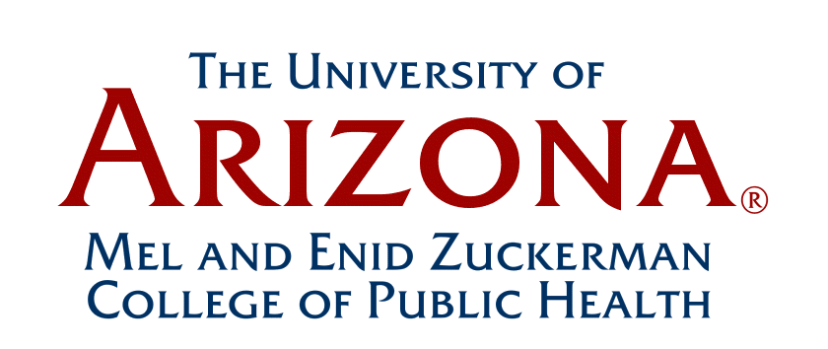
Faculty Assembly Minutes
January 17, 2014
“Final”
12:00-1:30 pm
Drachman Hall A116

Faculty Present: Jeff Burgess, Acting Chair
Zhao Chen, Leslie Dennis, John Ehiri, Kacey Ernst, Janet Foote, Iman Hakim, Robin Harris,
Mary Kay O’Rourke, Cecilia Rosales, Nicole Yuan, Jin Zhou

Other MEZCOPH Personnel:
Kathleen Crist, Coordinator, MEZCOPH Academic Curriculum and Faculty Affairs
Chris Tisch, Assistant Dean, MEZCOPH Student Services & Alumni Office
Linda Tumellie, Assistant Dean, MEZCOPH Financial Affairs/Physical Resources
Jill de Zapien, Associate Dean, MEZCOPH Community Programs

Guests:
Gary Esham, Director, Research Operations – UA Office of Senior Vice President for Research
Caroline Garcia, Associate Vice President, Research, UA VP for Research Office
Lori Ann Schultz, Assistant Director, UA Sponsored Projects-Services

- Review of Previous Meeting Minutes: (Jeff Burgess)
Review of November 2013 “draft” meeting minutes: Tabled

- University of Arizona Research Office - Proposal Submissions:
(Linda Tumellie, Caroline Garcia, Lori Ann Schultz and Gary Esham)

Linda Tumellie introduced Caroline Garcia, Associate VP for Research and Lori Ann Schultz, Assistant Director for Sponsored Project. Linda stated that the Research Office personnel were invited to speak at the Faculty Assembly meeting today, as MEZCOPH has had a recent problem with late proposal submissions, and the College recently received a reprimand from the VP’s Office for Research. Caroline Garcia and Lori Ann Schultz gave a brief overview of their backgrounds, and spoke to MEZCOPH faculty regarding University policies and procedures pertaining to UA proposal submissions and research compliance issues.

Key points from discussion:

- UA Research Office Motto: “Help Us to Help You” – Get proposal routing started early to avoid problems. Please contact sponsored projects and the research office with your questions to avoid “non-compliance issues”.

- MEZCOPH guidelines for proposal submission are also attached below for reference:

- Sponsored Projects Three-Day Deadline for Proposal Submissions
All proposals, paper and electronic, should be submitted to Sponsored Projects in final form 3 business days prior to the funding-agency deadline.
(Please refer to the following website for further information and details regarding UA proposal submissions): http://www.sps.arizona.edu/proposal/3D%20Memo%203day%20Policy.htm

- Sponsored Projects will not guarantee on-time submission for any proposal submitted after the 3-day deadline.

- Proposal deadlines impact many different sponsors (federal, state, other) at the same time. Because these overlaps occur so often, it's important for us to level the submission field so that all proposals receive proper attention from a proposal reviewer at Sponsored Projects. A given deadline may have NIH, NSF, State of Arizona, and USDA proposals coming through our office. If any
one proposal requires extra attention, it has a negative impact on all other submissions we receive on the same day. The 3-day deadline for all proposals allows us to prioritize our workload effectively and work with individual faculty and departments to ensure timely submission.

- New UA Research Office “Gateway” website project (currently under construction) Goal of the website is to create a user “toolkit” to help UA programs initiate large proposals. Investigators will have one website to go to for research assistance, research tools, and support for faculty and investigators and administrative services (see attachment handout below which illustrates the new research website infrastructure):

For further information, please reference the UA Vice President for Research website: https://vpr.arizona.edu/

- Caroline also reported that the University is currently hiring a new Research Development Director and (3) new research development officers. The goal for the Research Development Office will be to go after large funding opportunities for UA faculty and investigators.

- Caroline Garcia introduced Gary Esham, Director, Research Operations – UA Office of Senior Vice President for Research: Gary gave an overview of his professional background and his new role as Director of Research Operations. Gary will be responsible for coordinating and monitoring the administration and operational actions that impact research and sponsored grants and contracts. He will contribute to the management of the fiscal, contractual, and administrative activities of externally funded contracts and grants in support of University research projects and creative endeavors. Gary will assist the Research Office with an organizational transformation of UA research operations, in order to achieve consistency of service, operational efficiency, and orientation to faculty and staff.

Gary was previously the Associate Dean for Finance and Administration for the University of Arizona College of Optical Sciences. Gary has a wealth of knowledge and expertise in sponsored projects administration, contracting, compliance, technology transfer, as well as experience in research organizational structures, and policy and procedure development (including global initiative research). Gary understands the challenges of international research projects. Gary’s office is also working with the UA Tech Launch office regarding research projects and business contract negotiations. Please do not hesitate to contact Gary with any questions you may have: gesham@email.arizona.edu

- Dean’s Update (Iman Hakim)

- MEZCOPH Hiring Plan:
Iman reported that two new PHPM faculty members have been hired:
  - Michael Halpern and Leila Barazza
There is still an open senior line position in the PHPM section.

In addition, a letter of offer for Dr. Muktar Aliyu, candidate for Professor and Director, Center of Excellence in Women’s Health (approved as our College’s SPFI appointment) is currently at the VPR’s office. Hopefully, Dr. Muktar Aliya will officially accept this offer.

Iman also reported two individuals who will be interviewing at MEZCOPH as potential faculty “spousal hires”, in the area of Health Outcomes (AHSC Strategic Plan themed based area of excellence). They will be meeting with MEZCOPH faculty and Dr. Joe “Skip” Garcia at the end of January.

Iman also asked the faculty to think about the current vacant junior faculty positions in the College, and how these positions could open up “other opportunities” referenced in the College’s strategic plan.

RCM2:
Iman reported that the University is still working on the RCM2 reimbursement model. The latest copy has been given to MEZCOPH Division Directors who can share with their Division faculty. The research component is hard to understand; University should have a finalized formula by the end of the semester.

On-line MPH Program:
Iman stated that the College is currently speaking with Pearson Embanet (one of 3 UA approved vendors) regarding an online MPH partnership assessment. The program details and logistics still need to be planned and approved by the Education Committee, Division Directors and Faculty. Doug Taren and the MEZCOPH Education Committee will be meeting with Pearson Embanet on February 5th to initiate discussion, exploration of an online MPH program and implementation details. No decisions have been made; no agreements have been signed. We will not be putting up any revenue with an online vendor; they will be doing the marketing, website design, module design, etc. The faculty member owns the course “intellectual content”. The vendor cannot sell or use material for another entity. Faculty asked if there has been an open discussion with College faculty?
Iman said yes, during the strategic planning meetings and workshops. Faculty workgroups discussed exploration of an online MPH program for the College. Online degree programs are the “wave of the future” and also part of the UA initiative – UA is going in this direction. “If We do it; We must do it well”.
Requests for online Public Health programs, and other disciplines are increasing (e.g. E- Universities: UC Berkley, John Hopkins, etc.).

- Iman reported that she would be traveling this month to join UA President Anne Hart and Mike Proctor, UA Vice President of Global Initiatives, as well as other deans, faculty and representatives from other UA Colleges, who will be visiting Oman and the United Arab Emirates, in order to meet with influential leaders and UA alumni to discuss existing and potential partnerships between the UA and universities and agencies in that region.

Meeting adjourned at 1:30 pm.

Next Meeting:

- The next faculty assembly meeting is scheduled for February 21, 2014.

___________________________________
Changes or corrections to the minutes should be submitted to:
Kathleen Crist, Coordinator, MEZCOPH Academic Curriculum and Faculty Affairs Office

Action Items:*

- Carry forward items for discussion to the February 21, 2014 Faculty Assembly Meeting agenda (Dan Derksen and Kathleen Crist)

- Send Dan Derksen agenda items / topics that MEZCOPH faculty would like to see addressed at the February 21, 2014 Faculty Assembly Meeting (All Faculty members)

